St Beghian Society Social Gathering

Friday 28th February 2025 - Armathwaite Hall - 7.00 for 7.30pm

Name ……………………………….............................................

House and Dates at School ………………………………...........

Address ……………………………….........................................

……………………………….......................................................

Tel (H)……………….….……… Mobile …………………..…..

e-mail address ………………………………...............................

The number of people in my party will be ……………………...

1. Name ……………………………….........................................

2. Name ……………………………….........................................

3. Name ……………………………….........................................

4. Name ………………………………………………………….

Order Form – select a number from the menu and insert it into the appropriate column:
Name 1 Name 2 Name 3 Name 4
Starter (1-4)
Main Course (5-8)
Sweet (9-12)

The cost is £39.00 per head.

I enclose a cheque for £……………… Made payable to
“West Cumbria Branch OSBC” or a BACS payment**:
Sort Code: 01-09-54 Account number: 83707689
** Please add your name if paying by BACS**

Cheques or BACS payments must be received as soon as possible to confirm reservation and guarantee a place. This event is likely to be oversubscribed. (If you cancel before 21stFebruary 2025, you will receive a full refund).
St Beghian Society Dinner Menu
28th February 2025
Starter
Roast butternut squash and parmesan soup. (v) (gfa) (1)
Tempura langoustine tails, lemon & garlic aioli, balsamic, rocket (2)
Chicken liver parfait, Estate spiced plum chutney, brioche (3)
Burrella, tomato and avocado salad, basil oil (vegan) (gf) (4)

Main
Braised Estate beef brisket, honey roast carrot, mash, Dijon mushroom sauce. (gf) (5)
Pan roasted pheasant breast, chive mash, chorizo, pea and baby onion jus (6)
Plaice fillets, crushed new potatoes, kale, broccoli, butter sauce (gf) (7)
Winter vegetable, goats’ cheese and sage wellington, tomato confit, fondant potato (v) (8)

Dessert
Chocolate truffle torte, orange gel, milk chocolate ice cream (9)
Crème brulee, passionfruit macarons. (gf) (10)
Peach melba sundae, raspberry, vanilla ice cream (11)
Cheese board, water biscuits, fruits & chutney (gfa) (12)

Tea and Coffee

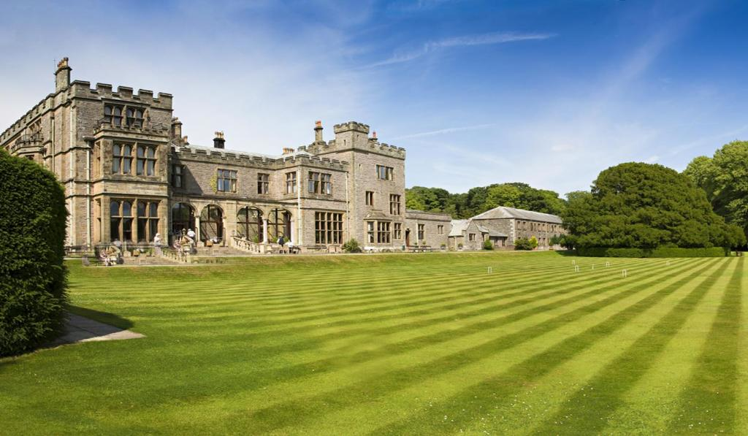
5, Marlborough Avenue  High Harrington  Workington  Cumbria CA14 4NW | 07970 180751 (M)  darryl.davies1@btopenworld.com

